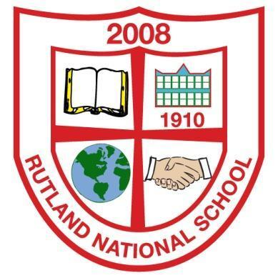
Rutland National School
Lower Gloucester Place
Dublin 1
Telephone: 01 874 7331
Email: secretary@rutlandns.ie
Principal: Niamh Murray

1st October 2025

RUTLAND NATIONAL SCHOOL
ANNUAL ADMISSION NOTICE
in respect of admissions to the 2026/2027 school year

Admission Policy and Application Form

A copy of the school’s Admission Policy and the Application Form for Admission for the 2026/2027 is available as follows: –
to download at: www.rutlandns.ie
or on request by emailing secretary@rutlandns.ie

Admissions to the 2026/2027 school year

Application and Decision Dates for admission to Junior Infants 2026/2027
The following are the dates applicable for admission to Junior Infants

The school will commence accepting applications for admission on | 1st October 2025
The school shall cease accepting applications for admission on | 16th January 2026
The date by which applicants will be notified of the decision on their application is | 30th January 2026
The period within which applicants must confirm acceptance of an offer of admission is | 13th February 2026

Note: the school will consider and issue decisions on late applications in accordance with the school’s admission policy.

Failure to accept an offer within the prescribed period above may result in the offer being withdrawn

Number of places being made available in 2026/2027
The number of places being made available in Junior Infants is | 19

Rutland NS will cooperate with the NCSE in the performance by the Council of its functions under the Education for Persons with Special Educational Needs Act 2004 in relation to the provision of education to children with special educational needs, including in particular by the provision and operation of a special class or classes when requested to do so by the Council. Rutland NS will comply with any direction served on the board or the patron under section 37A and 67(4)(b).

PART 2 - Admissions to the previous school year 2025/2026
(This section should only be completed if your school intake group/ special class was oversubscribed in the previous school year)
Information regarding the admission process for last year’s intake group for Junior Infants

In respect of the last school year (2025/2026), the total number of applications for admission received by the school was - 38
Breakdown of places allocated for the 25/26 school year:
Number of places available: | 19
Number of applications received: | 39
Number of Offers made and accepted under each criteria: | A description of each criterion used and the number of places offered and accepted under that criterion must be entered here  Criterion One:  siblings – 8  attending Holy Child Preschool & resident - 7  Criterion Two: Resident - 4
Total number of offers made | 19
Number of names placed on waiting list for the school year concerned. | 20

